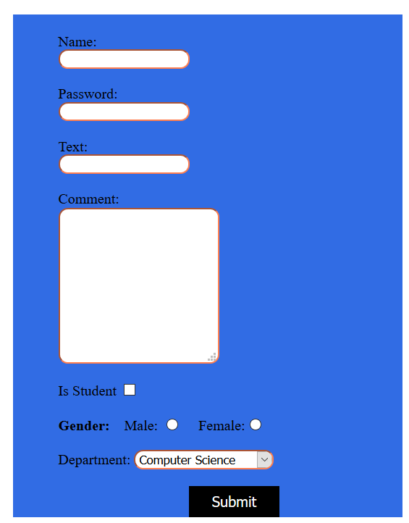

1. Create the html page as shown in the figure. You have to at least add following styles as shown in the figure:
   * 1. Make textboxes round
     2. Set textbox border color.
     3. Set the color of text inside textboxes.
     4. Set the background and foreground color of submit button.

Note: You can add CSS either as inline, internal or external.

**The following task is optional and will not be graded.**

* Now apply JavaScript such that when the button is pressed, it checks whether:
  + 1. All input textboxes have been filled.
    2. The option of gender has been selected.
    3. The password has the length of 6.
    4. The password contains at least 1 integer and 1 alphabet.

If any of the above mentioned conditions is not satisfied, show an appropriate message.